Structural Design Pattern

Composite Design Pattern

Aim:
The aim of implementing the Composite design pattern in this context is to create a computer part system capable of representing hierarchical structures of computer components and composite parts, facilitating the organization and management of complex configurations within a computer assembly.

Description:
The Composite pattern implemented in this code facilitates the creation of hierarchical structures for computer parts, allowing composite parts to contain both individual components and other composite parts. By offering a uniform interface for manipulation, the code simplifies the management of computer assemblies by treating leaf components and composite parts uniformly. This approach enhances extensibility and maintainability as new components can be easily added without modifying existing code. Leveraging recursion, operations such as displaying the price structure are efficiently executed. Overall, the pattern provides an elegant solution for representing and managing complex configurations of computer parts, promoting code reuse and enhancing organizational clarity within computer assembly systems.

Code:

1. ComputerPart
package com.deb.composite;

import java.util.*;

interface Component
{
void showPrice();
}

class Leaf implements Component
{
int price;
String name;

public Leaf(int price, String name)
{
this.price = price;
this.name = name;
}

public void showPrice()
{
System.out.println(name+": price");
}
}

class Composite implements Component
{
String name;
List<Component> components=new ArrayList();

public Composite(String name)
{
this.name = name;
}

public void addComponent(Component com)
{
components.add(com);
}

public void showPrice()
{
System.out.println(name);
for(Component c:components)
{
c.showPrice();
}
}
}

public class ComputerPart {
}

2. CompositeTest

package com.deb.composite;

public class CompositeTest {
public static void main(String[] args)
{
Component hd = new Leaf(4000, "harddrive");
Component mouse = new Leaf(4000, "Mouse");
Component monitor = new Leaf(4000, "Monitor");
Component ram = new Leaf(4000, "RAM");
Component cpu = new Leaf(4000, "CPU");
Composite ph = new Composite("Peri");
Composite cabinet = new Composite("Cabinet");
Composite mb = new Composite("MotherBoard");
Composite computer = new Composite("Computer");

mb.addComponent(cpu);
mb.addComponent(ram);

ph.addComponent(mouse);
ph.addComponent(monitor);

cabinet.addComponent(hd);
cabinet.addComponent(mb);

computer.addComponent(ph);
computer.addComponent(cabinet);

ram.showPrice();
ph.showPrice();
computer.showPrice();
}
}

Output:
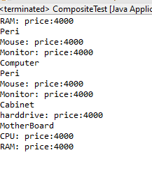

Class Diagram:
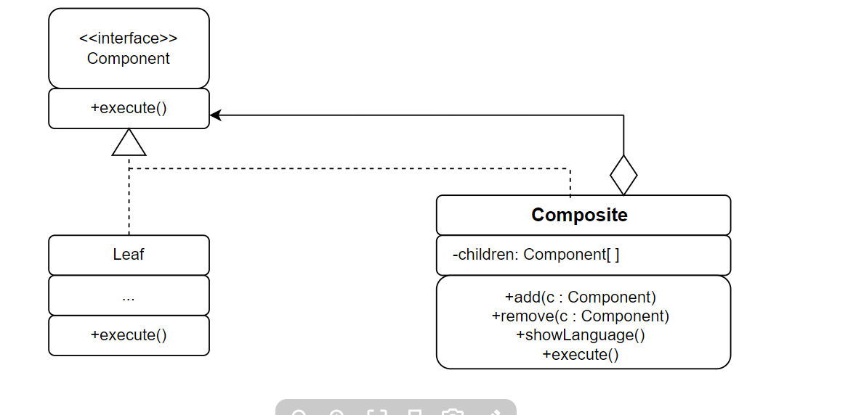

Aim:
The aim of implementing the Composite design pattern in this context is to create a computer part system capable of representing hierarchical structures of computer components and composite parts, facilitating the organization and management of complex configurations within a computer assembly.

Description:
The Composite pattern implemented in this code facilitates the creation of hierarchical structures for computer parts, allowing composite parts to contain both individual components and other composite parts. By offering a uniform interface for manipulation, the code simplifies the management of computer assemblies by treating leaf components and composite parts uniformly. This approach enhances extensibility and maintainability as new components can be easily added without modifying existing code. Leveraging recursion, operations such as displaying the price structure are efficiently executed. Overall, the pattern provides an elegant solution for representing and managing complex configurations of computer parts, promoting code reuse and enhancing organizational clarity within computer assembly systems.

Code:

1. MenuExample.java

package Personal;

import java.util.ArrayList;
import java.util.List;
import java.util.Scanner;

// Component interface
interface MenuComponent {
void display();
}

// Leaf class representing a single menu item
class MenuItem implements MenuComponent {
private String name;

public MenuItem(String name) {
this.name = name;
}

public void display() {
System.out.println(name);
}}

// Composite class representing a menu containing submenus or menu items
class Menu implements MenuComponent {
private String name;
private List<MenuComponent> menuComponents = new ArrayList<>();

public Menu(String name) {
this.name = name;
}

public void add(MenuComponent component) {
menuComponents.add(component);
}

public void remove(MenuComponent component) {
menuComponents.remove(component);}

public void display() {
System.out.println("Menu: " + name);
for (MenuComponent component : menuComponents) {
component.display();
}}}

public class MenuExample {
public static void main(String[] args) {
// Create main menu
Menu mainMenu = new Menu("Main Menu");

// Create submenus
Menu fileMenu = new Menu("File");
Menu editMenu = new Menu("Edit");
Menu viewMenu = new Menu("View");

// Add submenus to the main menu
mainMenu.add(fileMenu);
mainMenu.add(editMenu);
mainMenu.add(viewMenu);

// Create menu items for the submenus
MenuItem newItem = new MenuItem("New");
MenuItem openItem = new MenuItem("Open");
MenuItem saveItem = new MenuItem("Save");
MenuItem exitItem = new MenuItem("Exit");
MenuItem cutItem = new MenuItem("Cut");
MenuItem copyItem = new MenuItem("Copy");
MenuItem pasteItem = new MenuItem("Paste");
MenuItem zoomInItem = new MenuItem("Zoom In");
MenuItem zoomOutItem = new MenuItem("Zoom Out");

// Add menu items to the submenus
fileMenu.add(newItem);
fileMenu.add(openItem);
fileMenu.add(saveItem);
fileMenu.add(exitItem);
editMenu.add(cutItem);
editMenu.add(copyItem);
editMenu.add(pasteItem);

viewMenu.add(zoomInItem);
viewMenu.add(zoomOutItem);

// Display the main menu
mainMenu.display();
// Simulate user interaction by selecting a submenu
Scanner scanner = new Scanner(System.in);
System.out.print("Enter the submenu to display (File/Edit/View): ");
String selectedMenu = scanner.nextLine().trim().toLowerCase();

// Display the selected submenu
switch (selectedMenu) {
case "file":
fileMenu.display();
break;
case "edit":
editMenu.display();
break;
case "view":
viewMenu.display();
break;
default:
System.out.println("Invalid submenu selection.");
}
scanner.close();
}}

Output:
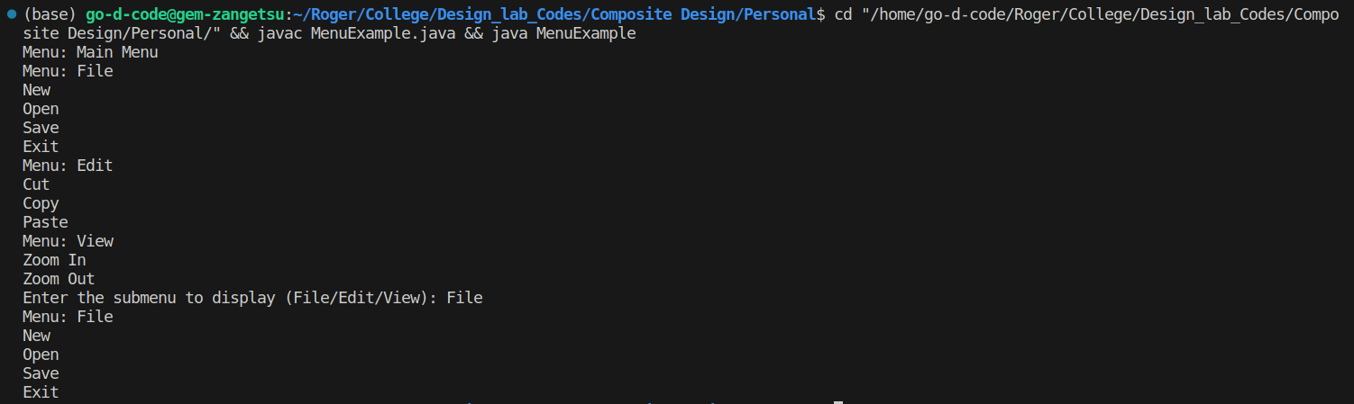
Class Diagram:
